**Software engineering**

### Project Proposal

**15/3/2019**

**Application of traffic monitoring in navigation software**

Team: Shadowrocket

Team Member:

|  |  |
| --- | --- |
| Name | FHSU ID |
| William | 66195207 |
| Chandler | 66088445 |
| Palmer | 23137342 |
| Caden | 84751102 |
| Guy | 84651951 |
| Jay | 49038231 |

Github URL: https://github.com/Devourd/traffic-monitor

Table of Contents

Page Title Page No.

Customer Statement of Requirements…….…….……….………………. 3

Glossary of Terms…………………………………………………………7

System requirements……………………………………………………....8

Functional Requirements Specification…………………………………...10

User Interface Specification…………………………………….…….......25

Project Management…………………………………………….…….......28

Task Assignment…………………………………………………………..31

Customer problem statement

Navigation software based on traffic monitoring has been widely used in people's large-scale life. In China, Gaode Navigation and Baidu Map are two major navigation software providers. They provide the best path navigation based on real-time traffic monitoring. These are the navigation software being used by users. They can provide users with the same time when the customer queries the road conditions and arranges the travel plan according to the database in the software system. The information is for the user to report the road condition and arrange the travel plan, but the user often does not start immediately after the inquiry. Therefore, since the road condition information at the time of the inquiry is inconsistent with the road condition information when the user travels, the user may be affected. Our project attempts to change the way the traditional navigation software is provided, and provides a prediction of the road conditions of the travel plan. If the user can set the travel time, then the information in the previous database can be used to arrange the travel of the customer. This method reduces the impact on the user's travel by conditions that can predict the impact of road conditions (such as weather causes, up and down peaks, holiday holidays...). According to the travel plan generated by the system and the reason that the system predicts that may affect the travel, the user has a general understanding of the entire trip, so as to select the favorite plan.

Our project is based on traffic monitoring technology to upgrade and upgrade existing navigation software. A Sias student plans to take the train home tomorrow. In order to improperly travel, he has to arrange his travel time reasonably. Since the school is some distance from Zhengzhou Railway Station, he plans to arrange his own time according to the navigation system. The navigation gave him the following plans 1: It takes about 1 hour to ride a car; 2: It takes about 10 hours to walk; 3: Take a bus, change it to 2 times in the middle, it takes 2 hours and 30 minutes. He chose to take the car from the school to the train station. In order to improperly miss the trip, he set off 2 hours and 30 minutes in advance the next day. The next day he took his luggage to the door of the European street, but because of the day there was a lot of The student had to go from school to Zhengzhou, causing the shortage of vehicles. After he had queued for 30 minutes, he got on the bus, but the vehicle just started to rain when the vehicle started to fly. The speed was reduced for the safety driver, but the speed of the vehicle was reduced. The vehicle was blocked on the highway, and the entire journey took 2 hours. When the students arrived at the train station, the train stopped checking and departed. Due to the weather, the road conditions changed. However, the classmate’s plan was based on yesterday’s road conditions, which led to a change in the class’s itinerary.

The navigation that appears in these markets, in order to make a plan, does not change the plan in time according to the weather conditions and road conditions, combined with the student's experience. We have improved the navigation on the market. We designed the system to collect all the information that can affect the road conditions. Then, according to the destination and time set by the customer, the plan will be revised according to the collected data. Until the customer starts to start the journey.

The plan that the user system can make for the household before departure

(1) The “Travel Plan” user has the following options:

A) Departure place: User enters the place of departure

B) Destination: User enters the arrival location

C) Time: User enters departure time

This plan is a plan that the system develops based on information collected that may have an impact on road conditions. This information includes weather, traffic at the same time in history, number of pedestrians on the road, etc... This plan is a plan that takes into account the information that can be predicted, but it does not only include these predictable changes in road conditions. In the case, there are still some unexpected situations that will change the road conditions, which will affect the user's travel and bring inconvenience to the users. In order to eliminate the unexpected situation, we have designed another method. The process is as follows:

(2) "Refresh plan" - adjust the plan according to the emergency situation

A) Interval: Set the time interval to collect information on the road conditions ahead.

B) Reset plan: According to the collected information, the system regenerates the plan and the user makes a new choice.

However, there are many uncertainties in these unexpected situations. Sometimes there are road jams in the car accidents on the expressway. Due to the traffic rules, we can only wait for the accident to be processed before we can start again.... We have no way to do this. Make changes, but in order to give the user a better experience, we set up a database information collection system.

(3) "Database"

A) "Reminder": User's radio button in the event of an emergency

B) “Problem feedback”: The multi-selection button and detailed problem description of the user's specific feedback on the problem encountered (in the case of security, or just button selection)

C): "Positioning Analysis": Analyze customer's problems with the user's location and the speed of the time traveled

After the user makes a reminder, the system will send a message reminder to all users who have plans for the road here, and also generate a new travel plan for these users.

Glossary of Terms

*Location Services* - Provide users with their own specific location information, as well as surrounding services

*Administrator* - Where to upgrade and maintain software operations

*Virtual map* - Generate the specific location and surrounding services of the location the user is querying

*Application* - A system that provides services to users based on information provided by users

*Weather service* - Collect weather from all parts of the user's plan, considering the impact of weather on users

*Location Search* - Help users understand the destination and surrounding location information

*Database* - Collect a large amount of information about road conditions, generate big data, and provide data for users to schedule

*Button* - Media that the user communicates with the system

*User interface* - The user enters the interface that the software intuitively sees.

*Algorithm* - The system generates a plan for the user.

System Requirements

Enumerated Functional Requirements

|  |  |  |  |
| --- | --- | --- | --- |
| functional requirement | Req-x | Priority weight | Requirement description |
| Req-1 | Customer login | 0.3398 | For personalized services, users need an account of their own to log in. |
| Req-2 | Accurate positioning | 0.2024 | The project is to plan the user's travel schedule in advance according to his preferences, and the positioning must be very accurate. |
| Req-3 | User preferences | 0.1975 | The competitiveness of the project lies in making predictions and providing a perfect travel experience, rather than simply following the shortest algorithm. Experience is calculated according to user preferences. |

Enumerated Nonfunctional Requirements

|  |  |  |
| --- | --- | --- |
| Non-functional requirements | priority | Furps+ requirement analysis |
| Multi-user simultaneous online use | 1 | To achieve the project release, there will be a lot of users to use, and the reliability requirements are the highest. |
| Reaction time not exceeding 5S | 3 | The waiting time of APP determines the user's favorite degree, and the performance requirement is the highest. |
| The system can run continuously in 7*24 hours. | 2 | The user's use time is very irregular, and the functional requirements are the highest. |

User Interface Requirements

|  |  |  |
| --- | --- | --- |
| User Interface Requirements | priority | User Interface Requirements Graphics |
| Map Search Box | 1 | Users need to enter the location to enter the itinerary NW$)GTBOWRVF0}D92EXVDHS.png |
| Determine the search key | 2 | ]1]~ZB6$}GXHBQML43CE6XD.png Users set up locations and need to search |
| Preference Setting Key | 3 | UV33XI07ZW7~CZE[JA%`FQF.png Users need to click on preference settings to get personalized itineraries |

**Functional Requirements Specification**

## Stakeholders

1. User
2. System administrator
3. Traffic management personnel
4. Investment company

## Actors and Goals

## Users need to access the main program to solve their own travel problems to understand the travel modes and travel directions they need.

The system administrator (initiating participant) administrator can run the system software normally, and solve the upgrade software according to the vulnerabilities and problems that occur in the software.

The application (participating participant) application is sent to the user in various ways (sound, text, image, etc.) and the program obtains the optimal result by calculating various factors affecting the user's travel.

The application can only be run on the mobile side through the App form.

The goal of the location search service is to determine where the user is located and the buildings around them.

The goal of the route service is to provide users with a fast arrival route after a large amount of calculations after the user enters the destination.

The goal of the virtual map service is to provide users with buildings (restaurants, pedestrian streets, etc.) around their destinations while viewing the map. If users are interested in certain locations, they can directly click on the relevant locations on the virtual map. operating

The purpose of the weather service is to provide the user with the detailed weather of their destination for the last fifteen days based on the user entering the destination they want to go, so that the user can be prepared.

The database stores data for all users on our software, which can be used to get results as fast as possible through data analysis.

The app will first access the user's last 15 days of travel plans and determine where they are located. It will show the user's location in a flat map, and of course provide a virtual map for the user. After the user enters the destination, it will provide all the travel modes from the user's departure point to the destination. After the user further selects the travel mode, it will display the real-time situation

of the route road and the weather conditions, and predict the possible problems of the road. To provide users with alternatives, after the user has a problem, the software can further provide solutions according to the problems generated by the user until the user reaches the destination that needs to arrive accurately.

Providing route and weather services is controlled by the administrator.

Provide location reports to users through location services configured on their smartphones. At the same time, the user is allowed to react to the live situation of the road through the App and store it in the database.

## Use Cases

REQ1: Add user

REQ2: User location targeting REQ3: Enter the destination

REQ4: Enter the estimated departure time or arrival time REQ5: Route planning and feedback to users

REQ6: User chooses the best way to travel REQ7: Add departure reminder

REQ8: Modify plan (optional)

|  |  |  |
| --- | --- | --- |
| Actor | Actor‘s Goal | Use Case Name |
| User | Enter a user name and password | UC-1 |
| User | Determine current position | UC-2 |
| User | Determine the address to go to so the software can start planning | UC-3 |
| User | Roughly how long it takes to plan the trip | UC-4 |
| User | View all routes and modes of travel | UC-5 |
| User | Choose the best route to make your trip easier | UC-6 |
| User | Don't forget your travel time | UC-7 |
| User | Consider alternatives (optional) | UC-8 |

USE CASE 1：Log in

|  |
| --- |
| USE CASE 1*：*Log in |
| **Related Requirem’ts:** REQ1, REQ7, REQ8  **Initiating Actor:** User  **Actor’s Goal:** Want to be able to record their own query results and history.  **Participating Actors:** User, Smart Phone  **Preconditions:** Software has the ability to create, store, and identify user credentials.  **Postconditions:** Provide login feedback.  **Flow of Events for Main Success Scenario:**  *→*User provides login request to software  *←*Provide user login interface  *←*User input credentials  *←*verify login credentials  *←*Successful verification (user login) / verification failed (re-enter credentials)  **Flow of Events for Extensions (Alternate Scenarios):**  *→*User provides login request to software  *←*Provide user registration interface  *→*User created credentials |

*←*Save credentials and feedback to the user

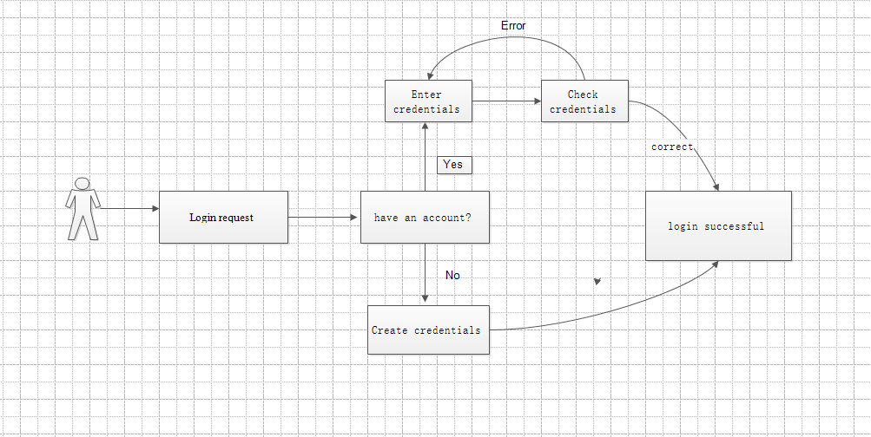

## Use Case-2：Query route

|  |
| --- |
| Use Case 2：Query route |
| Related Requirements: REQ2 and REQ3 Initiating Actor: User  Actor’s Goal: To locate and get directions Participating Actors: Traffic database, User  Preconditions: The user registers and logs in to the software, and the software locates the user in real time and analyzes the data.  Postconditions: The software records the navigation route in the traffic database  Flow of Events for Main Success Scenario:   1. The user logs in to the navigation software. 2. The system updates the map to locate the user's location in real time. 3. The system prompts the user to enter a destination. 4. The user enters the destination and submits. 5. The system prepares a data query that best matches the user's search criteria. 6. Through the traffic database query, the system handles. 7. Data feedback and plan the best route. 8. System (a) displays the selected record and confirms the request; (b)   archives the request in the database and routes it; (c) displays the route and navigates in real time. |

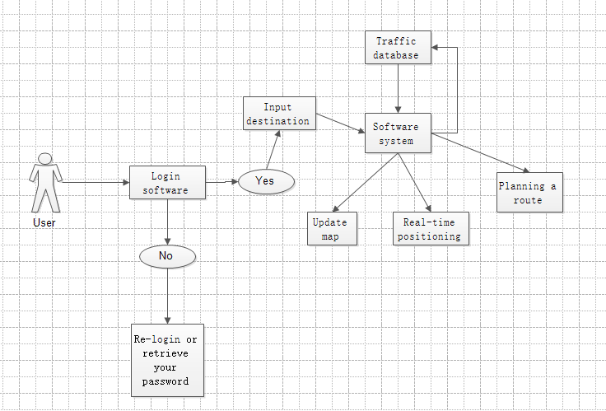

**Use Case 3：Set reminders and modify plans**

|  |  |
| --- | --- |
| Use Case | Set reminders and modify plans |
| Related Requirements: | REQ7，REQ8 |
| Initiating Actor | User |
| Actor’s goal | The user needs to set the departure reminder time or modify the travel plan before departure. |
| Participating Actors: | user database |
| Preconditions | The user enters the software to set the departure time or modify the plan. |
| Postconditions |  |
| Flow of Events for Main Success Scenario | 1. The user logs in to the software and enters the user interface.  2. Click the setup option to set the desired travel time  3. Data information is transferred to the database  4. The software system manages the processed information and reminds the user to travel at a predetermined time.  5. Change travel plan or cancel in user settings.  6. Data information submitted to the database  7. The software system prompts that the travel information has been successfully changed or cancelled successfully. |

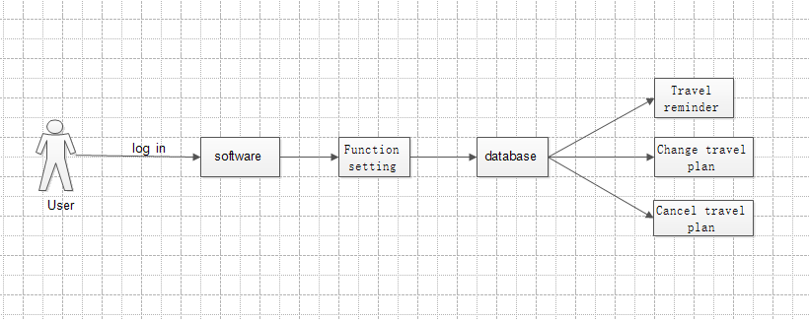

### Use Case 4：User Location

|  |  |
| --- | --- |
| User case | User Location |
| Related Requirem’ts | Open Mobile GPS Access |
| Initiating Actor | user |
| Actor’s Goal | Open position, automatic positioning |
| Participating Actors | Smart phones, hands,GPS |
| Preconditions | Have the location and storage rights of mobile phones. Open APP |
| Postconditions | Open GPS |
| Flow of Events for Main Success Scenario | 1.Open APP at the current location 2.Enter the search button 3.Display the current location |

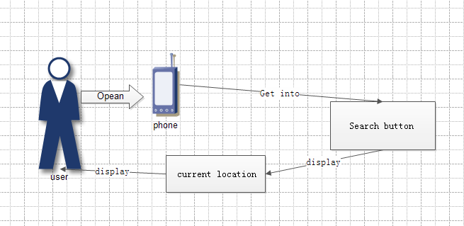

Use Case 5：User Location

|  |  |
| --- | --- |
| User case | Route planning and feedback to users |
| Related Requirem’ts | Open the mobile phone GPS access. |
| Initiating Actor | user |
| Actor’s Goal | Open position, automatic positioning |
| Participating Actors | Smartphones, Hands, GPS |
| Preconditions | Have the location and storage rights of mobile phones. Open APP. |
| Postconditions | Running Settable Preferences Algorithms. |
| Flow of Events for Main Success Scenario | 1. Open APP at the current location 2. Enter the search button 3. Display the current location 4. Input destination 5. Choosing Personal Preferences 6. Display personal paths |

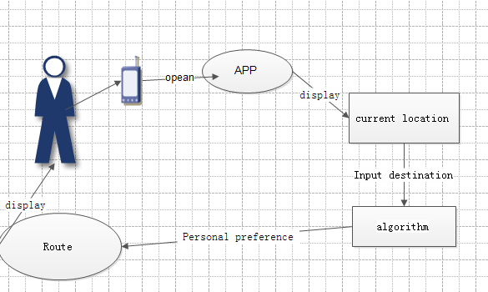

**Use Case 6: Choose a travel plan**

|  |  |
| --- | --- |
| Use Case 6*：* | Choose a travel plan |
| Related Requirem’ts: | REQ3*，*REQ4*，*REQ6 |
| Initiating Actor: | User |
| Actor*‘*s Goal | The user chooses the system to plan the plan that best suits his or  her travels. |
| Participating Actors: | Database, User |
| Preconditions: | User enters his own destination departure time  The system generates and  develops a variety of plans for users to choose |

|  |  |
| --- | --- |
| Postconditions: | Nothing worth mentioning |
| Flow of Events for Main Success Sccnario: | 1. Multiple optional travel plans appear on the user software interface 2. The user selects one according to their own time and enters 3. After entering, you can view the simulation and see if you are   satisfied. |

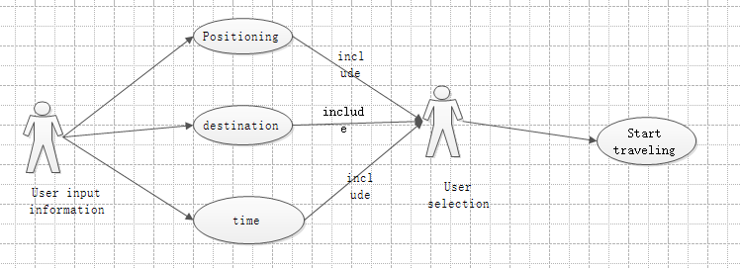

|  |
| --- |
| USE CASE 7*：*Add a departure reminder |
| **Related Requirem’ts:** REQ1, REQ6, REQ7  **Initiating Actor:** User  **Actor’s Goal:** Want to be reminded at a specific time before departure.  **Participating Actors:** User, Smart Phone |

**Preconditions:** The user has made a travel plan and the phone has a reminder function.

**Postconditions:** Mobile phone vibration / ring alert

**Flow of Events for Main Success Scenario:**

*→*User input is reminded by mobile phone before (?) minutes/hour before travel.

*←*Software saved and transmitted to the phone alarm clock software.

*←*Alarm reminder

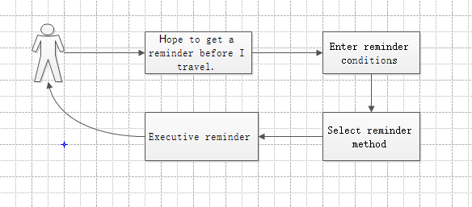

## Use Case 8

|  |  |
| --- | --- |
| Use Case 8*：* | Modify travel plan |
| Related Requirem’ts: | REQ6*，*REQ8 |
| Initiating Actor: | *系统* |
| Actor‘s Goal | The system selects the avoided road based on the sudden situation of the road condition received by the feedback, and the system regenerates the plan. |
| Participating Actors: | database |
| Preconditions: | The user has feedback on the road condition, and the system receives an unexpected situation in the |

|  |  |
| --- | --- |
|  | planned road conditions for the user. |
| Postconditions: | Nothing worth mentioning |
| Flow of Events for Main Success Sccnario: | 1. 1. Have feedback from the user about the road condition or the system collects information about the condition of the road. 2. 2. There are unexpected situations in the planned road conditions of the user in the database. 3. 3. Remind users to regenerate the plan |

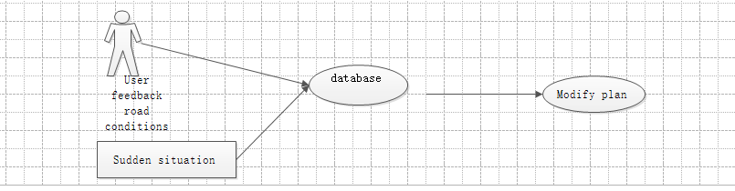

#### System Sequence Diagrams:

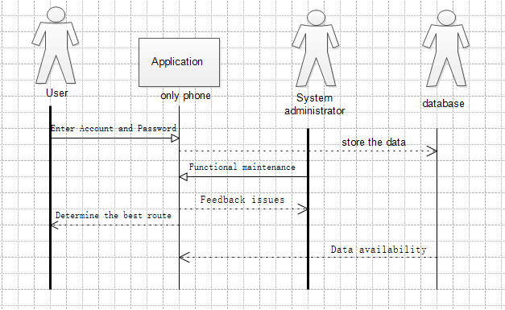

#### User Interface Specification：

According to the software function design, the user will go through the following steps：

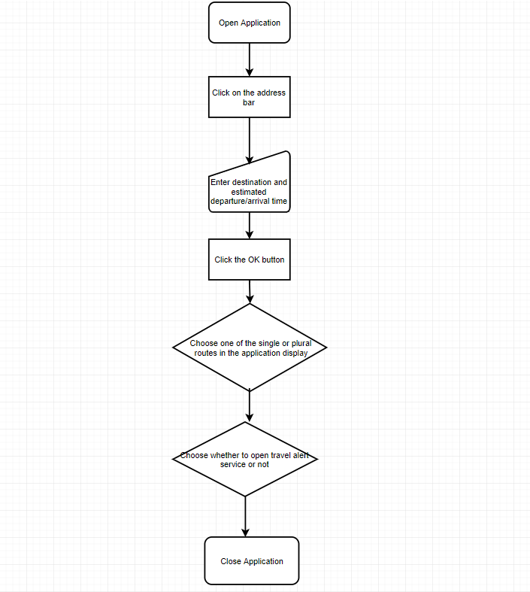

|  |  |  |
| --- | --- | --- |
| Operation | Example | Remarks |
| Open Application |  |  |
| Click on the address bar |  |  |
| Enter destination |  |  |
| Enter departure/arrival time |  | This function will be added to the navigation software. |
| Click the OK button |  |  |

|  |  |  |
| --- | --- | --- |
| Choose one of the single or plural routes in the application display |  | On this page, the departure and arrival times are expected to be added to the options for reference. |
| Choose whether to open travel alert service or not |  | This function is designed to avoid travel time forgetting caused by long time elapse. |
| Close Application |  |  |

Project Management

Plan of Work :

Our early work plan has a linear progression that breaks down the entire project into several parts. Then assigned to each group member. We hope that every part of the project will be completed smoothly. In order to improve work efficiency and quality of work, we divided the team into groups to do the following:

Final history of work:

|  |  |  |
| --- | --- | --- |
| Milestones | Completion Date | Group |
| Initial database script | 3/29 | Palmer and Caden |
| Traffic data collection | 4/3 | William and Chandler |
| Weather data collection | 4/10 | Guy and Jay |
| Traffic algorithm and weather algorithm | 4/18 | William and Caden |
| Flow algorithm and direction algorithm | 4/22 | Palmer and Chandler |
| Create a user profile database | 4/28 | Guy and Jay |
| Traffic map | 4/30 | Palmer and Caden |
| Navigation software user interface | 5/3 | William and Chandler |
| Schedule a navigation route | 5/17 | Guy and Jay |
| Mobile integration test | 5/31 | William and Caden |
| user experience | 6/15 | Guy and Jay |

Current achievement

(1) Navigate the data collection of user needs, analyze the data, and determine the research direction.

(2) Create a navigation system and user profile database

(3) Flow algorithm, direction algorithm, traffic and weather prediction algorithm.

(4) Improve the accuracy of traffic maps.

(5) Design the user interface of the navigation software.

(6) Traffic conditions and weather updates in real time.

(7) Mobile traffic data report.

(8) Scheduled reservation navigation service

Our current navigation software provides services on mobile mobile devices. Users can visit the website, log in and verify the user, and locate the location of the user in real time. The navigation software plans the best route and alternative route according to the user's needs. The traffic monitor is for the user. The navigation route is monitored in real time and fed back to the central management system to predict traffic and weather emergencies and to plan the most appropriate route. At the same time, our team also created an offline map database, using Beidou satellite to implement positioning, even in rural areas, suburbs and other areas with poor network signals can be navigated. The software page allows you to view traffic maps offline, 3D map mode, and emergency services. Compared to other navigation software, our products can provide scheduled appointment navigation route service, so we need to establish a reservation mode navigation route database. Finally, our data collection script runs without problems.

Future of work :

  For our current navigation software, we will do a lot of work in the future to improve and optimize the software to provide better services to users. The huge data information will destroy the existing database information, so it is very important to improve the user information database. More accurate calculations of driving speed, time, weather, traffic and the user's current location. We can establish a database of information on traffic accidents based on the user's driving route and the location of the traffic accident, reminding users who will pass the accident site and providing appropriate driving speed or other routes. The accuracy of navigation depends on our algorithm, and we must improve and improve the algorithm. The traffic information database needs to be updated frequently so that users can view the latest traffic information. Improve the speed at which traffic monitors collect traffic accident information and be able to view road conditions. For the navigation system in the reservation mode, the requirements for planning the navigation route are very high. After the judgment of the traffic monitor, the comprehensive information such as the prediction of the weather satellite can finally plan the best route in advance. Therefore, we need to improve the accuracy of the number of road traffic monitors, flow algorithms, direction algorithms, traffic and weather prediction algorithms.

Task Assignment:

|  |  |  |  |  |  |  |  |  |  |  |  |  |
| --- | --- | --- | --- | --- | --- | --- | --- | --- | --- | --- | --- | --- |
| Team Name: Shadowrocket | | William | | | Chandler | | Palmer | | Caden | | Guy | Jay |
| Responsibility levels | Project management | | 65 % |  | | 15 % | |  | | 10 % | | 10% |
| Sec.1: Customer Problem Statement | |  |  | |  | | 50 % | | 20% | | 30 % |
| Sec.2: System Requirements | |  | 75 % | |  | |  | |  | | 25% |
| Sec.3: Functional Requirements Specification | | Use Case 1 and Use Case 7 | Use Case 4 and Use Case 7 | | Use Case 3 and Use Case 7 | | Use Case 2 and Use Case 8 | | Use Case 5 and Use Case 8 | | Use Case 6 and Use Case 8 |
| Sec.4: User Interface Specs | | 75% |  | | 10% | |  | | 15% | |  |
| Sec.5: Plan of Work | |  |  | |  | | 100% | |  | |  |